Batch: T6
Asssignment No: 2
Title of Assignment: PSM and Object Relation Databases
Student Name: Harshavardhan Bamane
Student PRN: 22510112

PSM Review
- After inserting 50 records into table
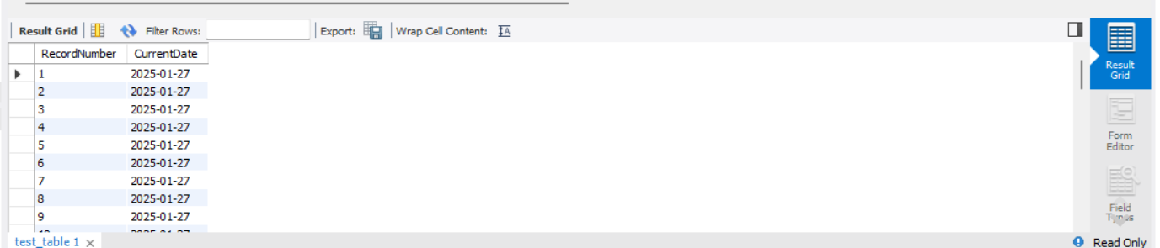

- Before using procedure
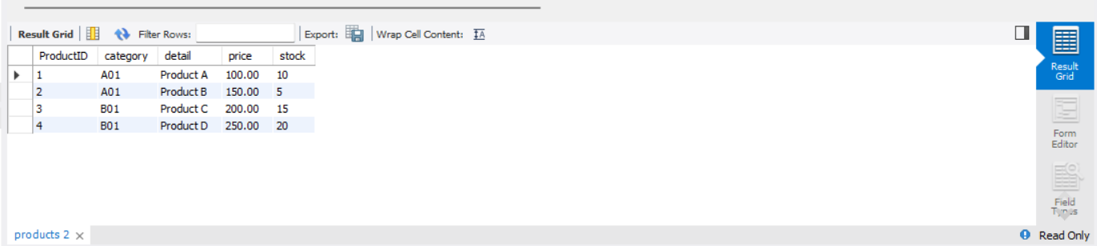
After using procedure
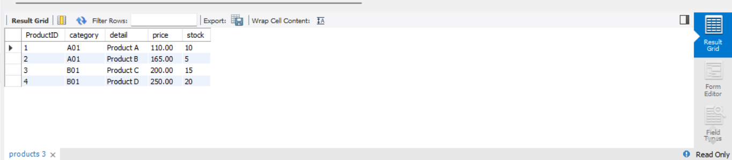

Object Relational Database
- Working of member function countOfWords for different words
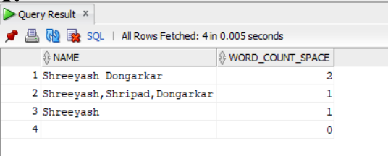
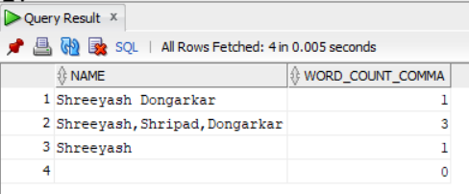

- Returning address based on keyword
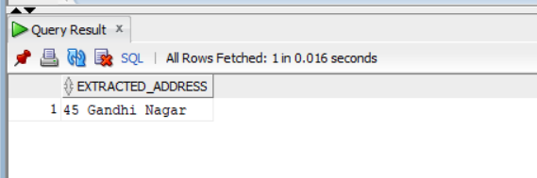

Returning no. of words for each record for each field
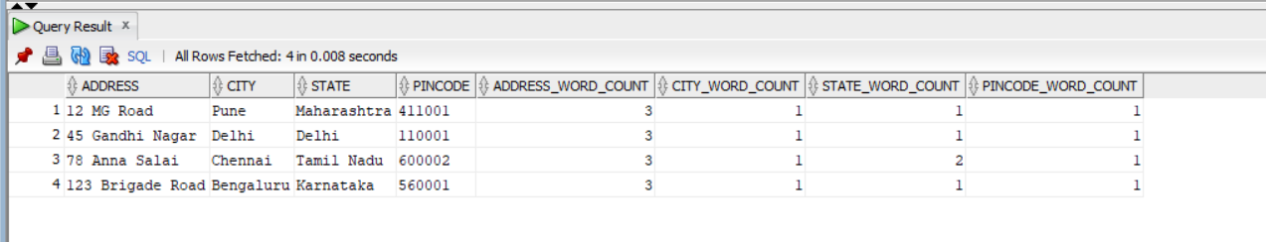

- Inserting into table with type courseType
